Facility Escape
  - CW1 Individual Report
Yaseen Hussain | Student ID [w2178106] | Group 5
3D Interactive Media Development | 12 November 2026

Project overview
This is an escape room which I assumed would be the best of options due to my experience with lua in Roblox developing Horror games, initially I took the wrong take on the project and provided a first-person perspective, which was corrected to a 3rd person view.

Room design and interaction
Room 1 is a chain of discoveries which provides a code to the player to unlock the door to the next room. The workshop provides a separate power requirement. Both the power objective and the correct code must be completed before the exit unlocks. This gives the player a reason to explore the room and use the tutorial controls, instead of treating the LEGO workshop as an unrelated demonstration.
The workshop opens through a labelled button in Room 1. It occupies a separate area within the same scene and uses its own camera. Returning to the room preserves progress, including discovered clues and restored power. Figure 1 shows the main room and its workshop entry point. Figure 2 shows the two coloured bricks, matching pads and individual animation controls. The images demonstrate the current layout; they are not evidence of a complete manual walkthrough.

Individual responsibilities
I was responsible for level 1.
Designed the room , the working hidden key puzzle input into the keypad system.
My work included the Rigidbody-controlled brick
This project helped me transfer my base/knowledge from lua to unity which was really fun.

LEGO movement and power objective
Power is restored when both bricks are sufficiently close to their matching pads. The script checks horizontal distances from the target positions and sets a persistent power-restored flag when both conditions are met. Room 1 checks this flag before allowing the keypad to unlock the exit. This connection makes the tutorial interactions relevant to the escape-room objective. It also creates a useful test case: entering the correct code before completing the workshop must not bypass the power requirement.

Minifigure animation and interface
An earlier Play mode test exposed a missing Animator component with the help of GPT to identify and the issue and provided instructions for the resolution ( Transparency provided at all times). The repaired code explicitly checks the Unity component and adds an Animator when needed. Each imported model is also placed under a separate parent object.

Integration between rooms
Completing Room 1 presents a control for continuing to the Power Room. Scene-specific initialisation prevents the Room 1 controller from appearing in the second room. The Power Room retains its switch-order puzzle, while the integrated flow adds a full game restart after completion. Restarting must rebuild the first room and clear its puzzle state. The final prototype therefore demonstrates a connected two-room experience.

Reflection and future development
For CW2, useful priorities include clearer visual clues, more consistent materials and lighting, improved feedback when a brick reaches its pad, and a stronger connection between the two room environment Ideally id like to show my work off in a 3d environment in a first person perspective ;;. Any additional rooms however should have a clear purpose in the overall sequence. The current prototype uses straightforward resolutions functionally , which are suitable for testing the concept but leave room for a more developed visual identity and more accessible controls.

Conclusion
Facility Escape currently combines two rooms, distinct LEGO control methods and independently controlled minifigure animations. The workshop supports the escape-room objective by restoring power to the first exit keypad.

References
[1] Group 5. Escape Room Unity project, main revision 2b6dde1. https://github.com/y4seen99-maker/Escape-Room (accessed 12 November 2026).
[2] Group 5. LegoTutorials.cs and EscapeRoomGame.cs, Assets/Scripts in the Unity project. Tutorial references recorded in code: 02–03 and 05.2. Lecturer-provided asset: LegoWalk.fbx.
[3] Escape room runtime regression results, 11 November 2026. Project test record: escape-regression-results.txt. 32 checks passed; manual interaction limitations described above.

Project screenshots
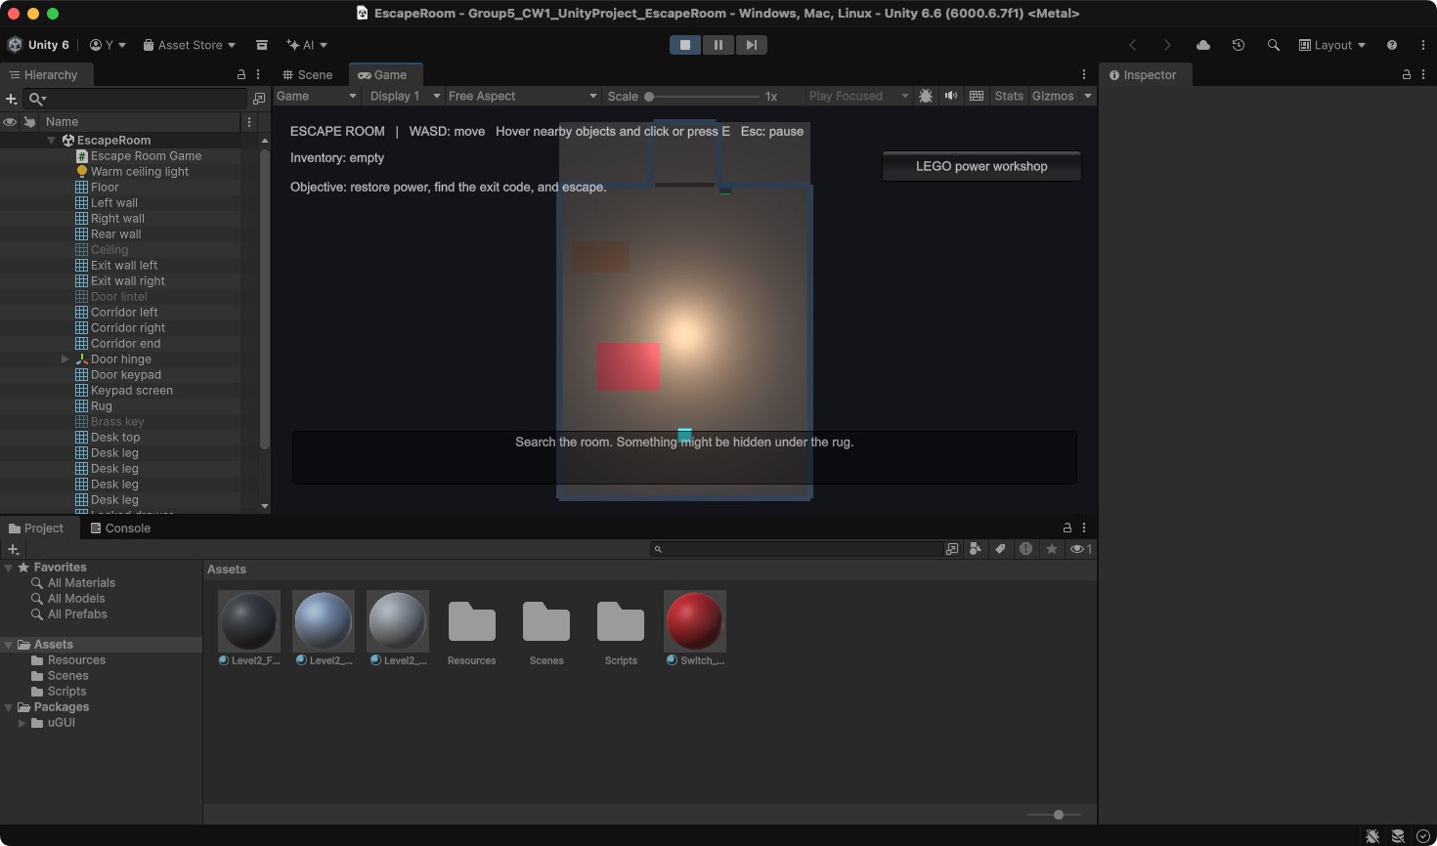
Figure 1. Room 1 in Unity Play mode, showing the overhead view, objective, clue prompt and LEGO workshop button.
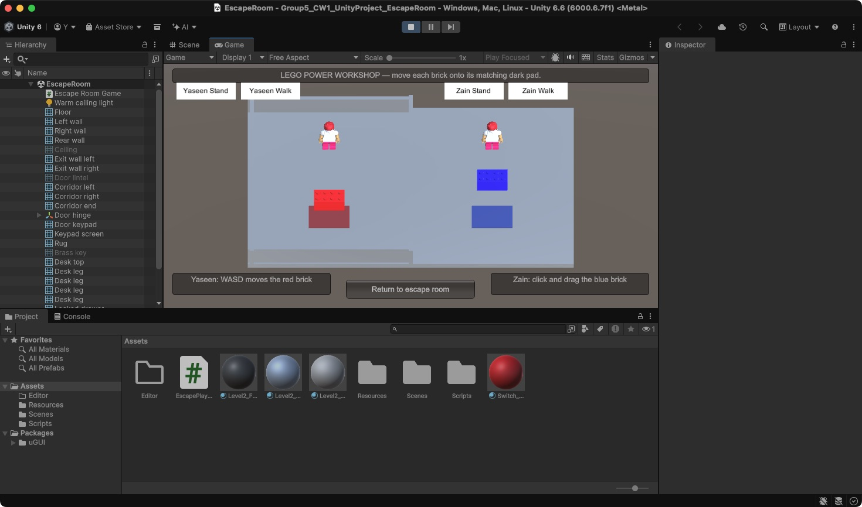
Figure 2. Integrated LEGO workshop with the two control methods, matching power pads and separate Stand and Walk buttons.

Declaration and supporting evidence
As you can see in figure 1 I used a blue block as the character , I used Chatgpt to provide a break down to adding a lego character and the movement.

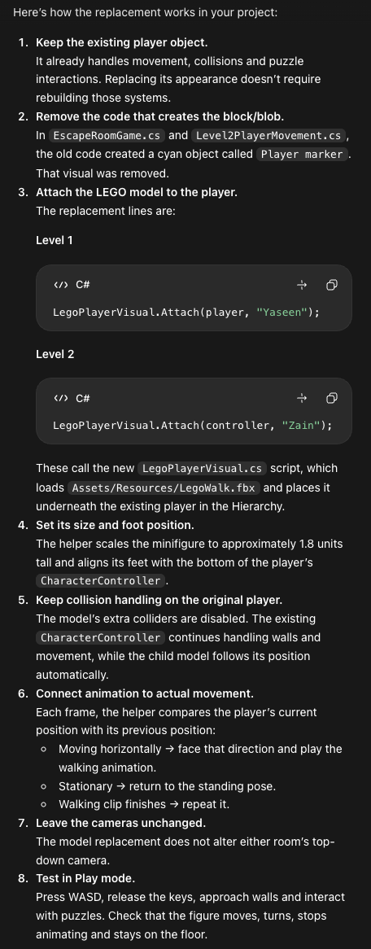
AI USAGE VIA CHATGPT BREAKDOWN OF ADDING LEGO CHARACTER.
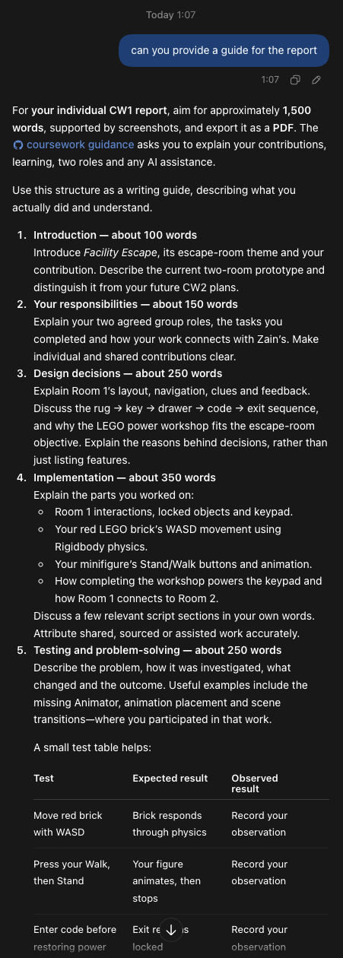
Guidance provided for structuring the report.

